Meeting Minutes

Rocco’s Tacos 5090 PGA Blvd, Palm Beach Gardens

November 17, 2018

5:00pm
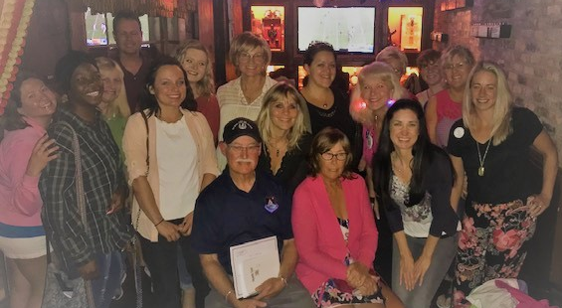

Call to order – Anita Mixon, Chair

Open issues / Old Business
- Minutes from past meeting(s) - Secretary
- Compass Rose – KFPR 2/9/2019 / 2/16/19
- Girl Scout Aviation Patch – F45 March 2019 (Daylight Savings Time starts 3/10/19; St. Patrick’s Day 3/17/19 – event target dates 3/9 or 3/23)

New business
- Raffle Ticket Sales for SE Section 99s
  - We have been asked to help with selling raffle tickets for cruise and quilt. Members to take a few tickets each; return money/proceeds to Anita monthly for submission to Section.
- Recent Fuel Contamination Incidents
  - Miami-Opa Locka Executive Airport (OPF)
  - https://www.faa.gov/other_visit/aviation_industry/airline_operators/airline_safety/safo/all_safos/
- Cookies for ATC – Michelle Rudolph
Members should contact Michelle to let her know quantity and type of cookies they will contribute. There will be a cookie exchange and holiday gathering at Meghan Traynor’s the evening of 12/14. The cookies will be delivered to PBI, KSUA and KFPR Control Towers on 12/15.
- Secretary & Webmaster positions
Discussed requirements of both positions and asked for volunteers. Asked that those interested in positions contact Anita.
- Best way to share TC99s information
- Discussion regarding Facebook page determined that posts unrelated to TC99s and re-posts of items already seen on other aviation and news pages (that most members already follow) has made our FB page irrelevant. That’s why there are no LIKES on any of the numerous daily posts. It was agreed that the TC99s FB page should only be for posting and sharing news relevant to TC99s: Photos and updates of our aviation highlights, our achievements, our checkrides, our new ratings, TC99s “in the news”, TC99s chapter information, etc.
- WhatsApp was suggested as the best technology tool to use for communication. This app works on both Android and IOS. I created a group named “Treasure Coast 99s”. We need to start adding our members to this group.
- I encourage all members to logon to https://www.ninety-nines.org/ and visit the Member Area (icon in upper left corner.) There is useful information, including the Member List (Directory) and Member Benefits.

- Lieutenant Colonel Shaw from National Civil Air Patrol, was our guest speaker. He gave us a history of the CAP, as well as an overview of the many programs they offer.

Committee Reports
If Committees meet separately from Chapter meetings, please submit minutes and/or written recap of meetings to Chapter Chair and Secretary.
- Financial Report – Jennifer Clarke, Treasurer
Jennifer will work with Anita and any other volunteer(s) to complete annual audit/review of financials.
- Membership Report – Anita Mixon
  - As of November 16, 2018: 48 current members; 1 stand-by member
  - Please remember to renew your International 99s Membership – Southeast Section, Treasure Coast Chapter. https://www.ninety-nines.org/membership-renewal.htm
  - TC99s Annual dues $12.00; due by May 31 each year.
- Aerospace and Safety Education – Kaye Ebelt, Education Chair
  - NASA has requested our participation in hosting 30 teachers for a STEM program the last week of July 2019.
  - https://www.ninety-nines.org/aviation-and-space-education.htm
  - https://www.eaa.org/eaa/news-and-publications/eaa-webinars
  - https://www.faasafety.gov/
- Community Outreach, Public Relations and 99 News
  - Discussed need for more exposure in the news. Press releases, social media, etc. needs to be updated so our community is aware of our contributions. This also helps promote membership. Volunteers working on website would be tasked to help in this area, but all members can help with this. I’ve added some links to news release forms that we can all use to submit information about our events. Please share any others you know of:
    - https://notables.palmbeachpost.com/noteworthy-news-form/
    - http://palmbeach.happeningmag.com/submit-press-release
    - http://static.tcpalm.com/forms/?wid=m1d8fjz416y5ar9
  - https://www.ninety-nines.org/email-networks.htm
If you have not yet joined 99s Google Groups, you can join from the group page. Go to https://groups.google.com/d/forum/ninetynines and click on "apply for membership" under the ninetynines group name. Please include your full name and Chapter affiliation when you apply for membership so we can verify your membership in the 99s.
  - Member Benefits & Discounts https://www.ninety-nines.org/member-benefits.htm
  - http://www.socialflight.com/#reg
- Scholarship – Jessica Meier, Vice-Chair, Scholarship Chair
  - Need volunteers to work with Chair to write TC99s scholarship and participate in selection committee. Discussed starting with a small scholarship, open to all members. Volunteers interested in working with Jess to write the scholarship and serve on the selection committee should contact Jess.
  - Other scholarships:
https://www.ninety-nines.org/scholarships.htm
http://sesection99s.org/id10.html
https://www.wai.org/education/scholarships
https://www.faa.gov/education/grants_and_scholarships/aviation/
http://www.flightschlolarship.info/
https://www.scholarships.com/financial-aid/college-scholarships/scholarships-by-type/aviation-scholarships/
  - Governance
http://sesection99s.org/id23.html

Meeting and Events Calendar
  - Tentative calendar - please feel free to share ideas for meeting times/locations and guest speakers:
http://www.treasurecoast99s.com/calendar.html
    - December 14 2018 – Cookie Exchange at Meghan Traynor’s (more info to follow); Cookies for ATC, December 15 (PBI, KSUA, KFPR)
    - December 9, 2018 – Gold Coast Holiday Scholarship Brunch Miami (Sunday)
    - January 12, 2019 – St. Simon’s Island, GA fly-in Hotel: (800)342-0212; Airport ramp space (912)638-8617. Georgia Flying Belles amychancey5853@gmail.com
    - Mid-January / early February – KSUA or KFPR meeting may be scheduled
    - February 9, 2019 Compass Rose Painting, KFPR (Saturday)
    - February 16, 2019 Rain Date for KFPR Compass Rose Painting (Saturday)
    - March 2019 – F45 Girl Scout Aviation Patch
    - April 2-7, 2019 Sun-n-Fun, KLAL
    - Late April / early May – TBA Stuart / Martin County (Tuesday evening)
    - May 12, 2019 – Ocean Reef Fly-In with Gold Coast 99s (Mother’s Day)
    - June 2019 – TBA Palm Beach County (Saturday)
    - July 2019 – no TC99s meeting (may have a social gathering, if there is enough interest)
    - July 16-21, 2019 – 99s International Conference, Dayton, OH
    - July 22-29, 2019 – Oshkosh Fly-in KOSH
    - August 10, 2019 PBI, F45, LNA or Jupiter Community Park (Saturday morning)
    - September 10, 2019 TBA Stuart / Martin County (Tuesday evening)
    - October 12, 2019 PBI, F45, LNA or Jupiter Community Park (Saturday morning)
    - November 9, 2019 TBA Stuart / Martin County (Saturday morning)

- Southeast Section 99s Section Meetings & Hosting Chapters:
http://sesection99s.org/id11.html
    - Spring 2019 Emerald Angels
    - Fall 2019 Kitty Hawk
    - Spring 2020 Florida Heartland
    - Fall 2020 Blue Ridge
    - Spring 2021 NOLA
    - Fall 2021 Carolinas

- New ratings and upcoming checkrides, birthdays, anniversaries, celebratory dates – share your Good News with us.

Adjournment
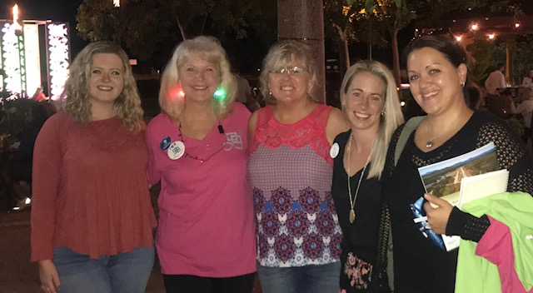
Submitted by: Anita Mixon, Treasure Coast 99s Chair

